Share this acu-connect webinar with your clients and prospects!
This web kit can be used to share the webinar for registration or on-demand after the live run date. This kit includes an email invitation and social content to share the webinar.
WEBINAR INFORMATION:
Supply Chain Under Stress – Best Practices for Turbulent Times
Featuring: V-Technologies and NetStock
June 5, 2020, 11am PT/2pm ET
WEBINAR REGISTRATION LINK:
https://creditcardprocessing.apspayments.com/acu-connect-webinar-june20?ref=partner
Note: If you would like your registrations tracked, change “partner” in the link above to your company name.
EMAIL SUBJECT LINE:
Supply Chain Under Stress – Best Practices for Turbulent Times
EMAIL BODY COPY:
Hi <NAME>,
From natural disasters to political unrest, disruptions can affect demand even during “normal” times. Best practices always call for the right mix of people, processes, and technology.
Join us for a webinar presented by acu-connect founding members V-Technologies and NetStock as they cover best practices for supply chain management during COVID-19 and beyond including:
- Demand planning
- Technology best practices with Acumatica
- Fulfillment by Amazon, Merchants, and Carriers
Supply Chain Under Stress – Best Practices for Turbulent Times
June 5, 2020, 11am PT/2pm ET
Register Today!
Contact your representative at <Insert Partner Name>: <Insert EMAIL> to learn more about these integrated solutions for Acumatica today!
<Insert Partner Name> is proud to be a member of acu-connect, THE network for the Acumatica community. Learn more at https://www.acu-connect.com/.

SOCIAL (LinkedIn/Twitter/Facebook suggested posts):
Join us on June 5 to learn best practices for @acumatica users in demand planning, fulfillment, and more during supply chain disruptions. https://creditcardprocessing.apspayments.com/acu-connect-webinar-june20?ref=partner #acuconnect #acumatica
Don’t miss this 6/5 webinar for @acumatica users: Supply Chain Under Stress – Best Practices for Turbulent Times presented by @ShipVtech and @NetStockInv https://creditcardprocessing.apspayments.com/acu-connect-webinar-june20?ref=partner #acuconnect #acumatica

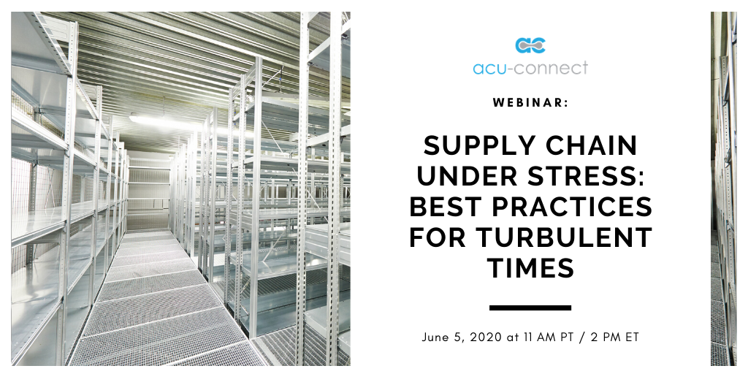
ACU-CONNECT MEMBER BADGES:
https://www.acu-connect.com/marketing-kit/
QUESTIONS?
Contact info@acu-connect.com

